Vice Chairman
Name | Tmt. T.Dhanalakshmi | 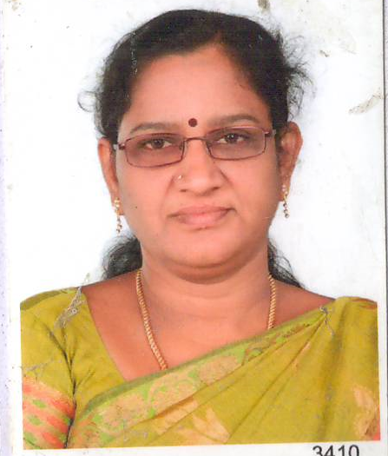
Mobile Number | 9976647590
Residence Address | 1A, Pavali road,Virudhunagar 626001

