Municipal Chairman
Name | Thiru.R.Madhavan | 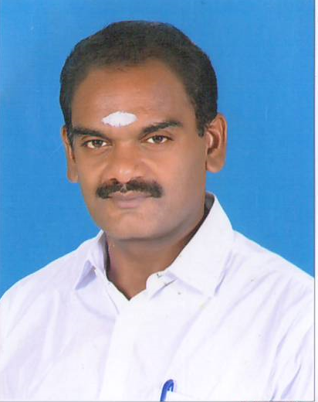
Mobile Number | 9443110450
Residence Address | 19, Kulloorsanthai road, Virudhunagar
e-mail

