## District Administration, Vellore – Preventive measures against Corona

* [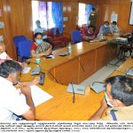](https://cdn.s3waas.gov.in/s31651cf0d2f737d7adeab84d339dbabd3/uploads/2020/04/2020040860-1024x749.jpg)[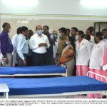](https://cdn.s3waas.gov.in/s31651cf0d2f737d7adeab84d339dbabd3/uploads/2020/03/2020032482-1024x736.jpg)[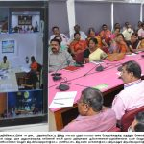](https://cdn.s3waas.gov.in/s31651cf0d2f737d7adeab84d339dbabd3/uploads/2020/03/2020032435-1024x365.jpg)[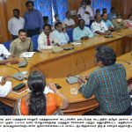](https://cdn.s3waas.gov.in/s31651cf0d2f737d7adeab84d339dbabd3/uploads/2020/03/2020032485-1-1024x610.jpg)
* [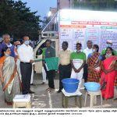](https://cdn.s3waas.gov.in/s31651cf0d2f737d7adeab84d339dbabd3/uploads/2020/03/2020032498-1024x733.jpg)[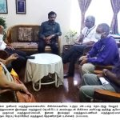](https://cdn.s3waas.gov.in/s31651cf0d2f737d7adeab84d339dbabd3/uploads/2020/03/2020032393-1024x553.jpg)[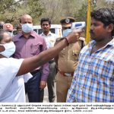](https://cdn.s3waas.gov.in/s31651cf0d2f737d7adeab84d339dbabd3/uploads/2020/03/2020032369-1024x757.jpg)[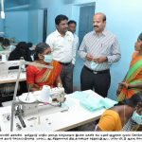](https://cdn.s3waas.gov.in/s31651cf0d2f737d7adeab84d339dbabd3/uploads/2020/03/2020032359-1024x736.jpg)
* [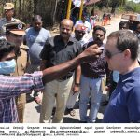](https://cdn.s3waas.gov.in/s31651cf0d2f737d7adeab84d339dbabd3/uploads/2020/03/2020031924-1024x795.jpg)[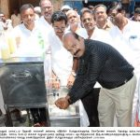](https://cdn.s3waas.gov.in/s31651cf0d2f737d7adeab84d339dbabd3/uploads/2020/03/2020031928.jpg)[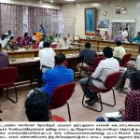](https://cdn.s3waas.gov.in/s31651cf0d2f737d7adeab84d339dbabd3/uploads/2020/03/2020032882-1024x544.jpg)[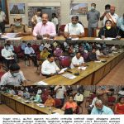](https://cdn.s3waas.gov.in/s31651cf0d2f737d7adeab84d339dbabd3/uploads/2020/03/2020032829-842x1024.jpg)
* [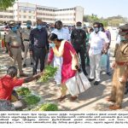](https://cdn.s3waas.gov.in/s31651cf0d2f737d7adeab84d339dbabd3/uploads/2020/03/2020033079-1024x783.jpg)[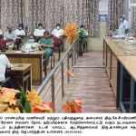](https://cdn.s3waas.gov.in/s31651cf0d2f737d7adeab84d339dbabd3/uploads/2020/04/2020040669-1024x436.jpg)[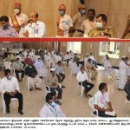](https://cdn.s3waas.gov.in/s31651cf0d2f737d7adeab84d339dbabd3/uploads/2020/04/2020040610-1024x632.jpg)[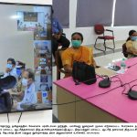](https://cdn.s3waas.gov.in/s31651cf0d2f737d7adeab84d339dbabd3/uploads/2020/04/2020040877-1024x367.jpg)