COVID 19 PREVENTION AND MANAGEMENT ACTIVITIES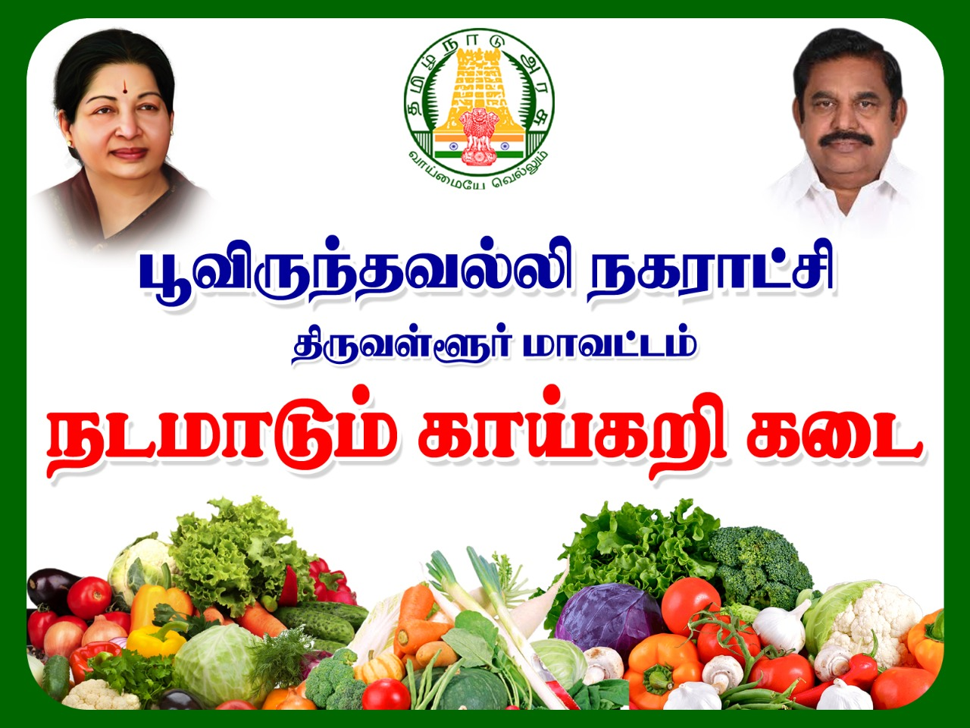
விழித்திரு, விலகியிரு, வீட்டிலேயே இரு
Poonamallee Municipality is providing the following Corona Preventive Activities on COVID 19
- Creating adequate awareness among the citizens in Poonamallee via Banners, Placards, Media, Vehicle announcements to take preventive measures against COVID 19.
- Continuous monitoring of Corona control activities of all streets.
- Conducting regular review meetings then and there by adopting social distancing.
- Helpline Control Room facilities available
- Disinfection activities done through Hand sprayers, Vehicle Mounted Sprayers, Mist Blowers and Other Vehicles on regular basis in all worship places, Public places, Government Hospitals and other public buildings.
- Maintaining Social Distance in Markets, Grocery shops and Other Areas.
- Free food is distributed in all Amma Ungavagam and also other needful areas.
DO’s
- Do wear a cloth covering on your face at all times when you are not at home.
- Do wash your hands before you wear your mask. Only touch the ear loops.
- Do practice good hand hygiene and wash your hands frequently.
- Do cover your cough or sneeze. The best way to cough or sneeze is into your elbow and not your hands.
- Do work from home. Do leave your home only for essential reasons, such as buying food or medication purposes.
- Do move away from others who cough or sneeze.
- Do wear a face mask and gloves if you are caring for a family someone who has tested positive for COVID 19.
- Do participate in “social distancing” to blunt the spread of the virus.
- Do self-quarantine yourself for 14 days if you come into contact with someone who tests positive for corona virus.
DON’Ts
- Don’t just tie a scarf around your face as that can be loose fitting and need more adjustment. Use a cloth covering that is more tight-fitting.
- Don’t touch your eyes, nose, mouth or face without washing your hands.
- Don’t interact with your pets if you think you may have symptoms concerning for COVID 19.
- Don’t treat “social distancing” like a “vacation”.
- Don’t share utensils or drinking glasses with others, including family members.
- Don’t shake hands or give hugs as greetings. Use an alternative greeting that maintains 6-8 feet of distance.
- Don’t visit your older relatives or community members, as they are the highest risk group.
- Don’t go to public places like gyms, theatres, restaurants, saloon and beauty parlours
- Consume foods which could increase immunity level.
- Don’t be panic over COVID 19 as excess fear and stress will decrease the immunity in our body.

